Oxford Resources for IB

IB Prepared Chemistry – 2023 Edition

Answers to practice exam papers

Paper 1
Section A
- D
- C
- B
- A
- D
- A
- D
- B
- B
- C
- A
- D
- B
- C
- D
- B
- C
- D
- A
- C
- C
- A
- D
- B
- A
- A
- C
- C
- A
- D
- C
- B
- A
- D
- B
- C
- A
- A
- A
- B
- D
- C
- B
- D
- C
- A
- C
- B
- C
- D

Section B

  - pH probe/(digital) pH-meter and temperature probe/(digital) thermometer.
  - Accuracy: calibrate both instruments; measure both values simultaneously; use digital instruments instead of analogue (to eliminate systematic errors caused by human perception); use high-purity water and a beaker made of inert material (to reduce effects of acidic or basic impurities on the solution pH); make sure that the thermometer does not touch the walls or bottom of the container with the studied sample (because the temperature of the container may differ slightly from the temperature of water inside it).
Precision: repeat each measurement several times and calculate the average value; use more precise instruments.
  - Independent variable: temperature (because it can be changed arbitrarily in the course of the experiment).
Dependent variable: pH (because the pH of pure water is a function of temperature).
  - Under standard pressure, water freezes at 0 °C and boils at 100 °C, so the pH of liquid water can be measured only within this range.
  - pH = 6.89. The acceptable range of answers is from 6.88 to 6.90. Notice that the distance between minor gridlines is 2 °C on the x-axis and 0.04 pH units on the y-axis.
  - Regardless of temperature, the dissociation of water produces equal amounts (and thus equal concentrations) of H⁺(aq) and OH⁻(aq) ions, as shown in part (i). Since [H⁺] = [OH⁻], pure water at 32 °C is neutral (neither acidic nor basic).
  - [H⁺] = 10^{−pH} = 10^{−6.89} ≈ 1.29 × 10⁻⁷ mol dm⁻³
In pure water, [OH⁻] = [H⁺], so:
K_{w} = [H⁺][OH⁻] = (1.29 × 10⁻⁷ mol dm⁻³)² ≈ 1.66 × 10⁻¹⁴ mol² dm⁻⁶
Alternative solution:
pK_{w} = pH + pOH. In pure water, pH = pOH, so pK_{w} = 6.89 + 6.89 = 13.78
K_{w} = 10^{−13.78} ≈ 1.66 × 10⁻¹⁴ mol² dm⁻⁶
  - To score full marks, both axes in your sketch must be labelled, and the curve must look similar to the one shown below, although it does not have to be drawn to scale.
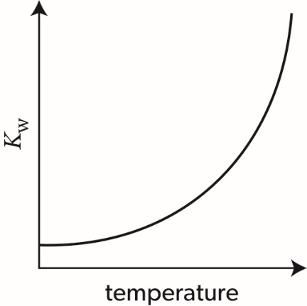
  - H₂O(l) ⇌ H⁺(aq) + OH⁻(aq)
An equation with 2H₂O(l) and with H3O⁺(aq) instead of H⁺(aq) is also acceptable.
  - The sketch in part (h) shows a positive correlation: as temperature increases, the Kw value also increases. If K_{w} increases, then both [H⁺] and [OH⁻] also increase. Therefore, an increase in temperature shifts the position of the equilibrium in part (i) to the right (towards products). This is possible only for an endothermic process, so $∆H^{⊖}>0.$

  - To score the first of the two marks, you need to mention any one of the following:
- measure the volume of gas released during the reaction / use a gas syringe / use an overturned measuring cylinder filled with water
- measure the mass (or mass loss) of the mixture / place the reaction vessel on an analytical balance
- measure the pH of the solution / use a pH probe
- measure the conductivity of the solution / use a conductivity probe
- plot the volume/mass (loss)/pH/conductivity as a function of time.
To score the second mark, you need to state that the initial rate can be determined from the slope of the tangent to the curve at t = 0.
  - n₁(HCl) = 0.0500 dm³ × 1.00 mol dm⁻³ = 0.0500 mol
n₂(HCl) = 0.0500 dm³ × 2.00 mol dm⁻³ = 0.100 mol
n₁(Zn) = $\frac{1.00 g}{65.38 g {mol}^{-1}}≈0.0153 mol$
n₂(Zn) =$\frac{10.0 g}{65.38 g {mol}^{-1}}≈0.153 mol$
The second method would be least affected because zinc was taken in excess, so any variations in its mass would only slightly affect the reaction time (due to slight differences in the surface area). In the first method, zinc was the limited reactant, so any variations in its mass would directly affect the reaction time.
  - Any one of the following: surface area, degree of dispersion, particle size, purity.
  - A larger surface area, a higher degree of dispersion or a smaller particle size will accelerate the reaction (due to the increased number of collisions between the reactant particles). A lower purity can either slow down the reaction (if the impurity is less reactive than zinc) or accelerate the reaction (if the impurity is more reactive than zinc).
  - No, it is not appropriate because the differences between individual measurements and their average value are much greater than 0.1 s.
  - Approximately 80 s. Notice that in reality the average time will be slightly less than 80 s because the concentration of the 2.00 mol dm⁻³ HCl(aq) will decrease during the reaction by a smaller proportion than that of the 1.00 mol dm⁻³ HCl(aq). However, you do not have to state this to score the mark.
  - Systematic error, as in all cases the stopwatch was started later than needed, so the recorded reaction times were consistently shorter than the actual reaction times.

  - The reaction produces a strong acid, HI, that can protonate the amino group in acridone:
R₂NH + H⁺ → R₂NH₂⁺
The protonated amino group has no lone pair on the nitrogen atom, so it cannot react with the electrophilic reagent (CH₃I). A base will neutralize the acid and thus prevent the protonation of the amino group in acridone, leaving more substrate available for the reaction with CH₃I.
  - Crude NMA is dissolved in the minimal volume of hot ethanol, the hot solution is filtered if required (to remove any insoluble impurities) and allowed to cool down. The crystals of pure NMA formed are isolated by filtration, washed with a small volume of cold ethanol and dried to constant mass.
  - Impurities usually lower melting point and make it less sharp (i.e. the product melts over a wider range of temperatures. Therefore, the recrystallized product will have a higher melting point and a shaper (narrower) melting range.
  - A small sample of the recrystallized NMA is dissolved in a suitable solvent (such as ethanol), and the solution is spotted on the start line drawn with a pencil on a piece of chromatographic paper. The paper is dipped into a suitable solvent in a covered beaker, making sure that the solvent level is below the start line. When the solvent front has moved up most of the paper length, the paper is removed from the beaker, the position of the solvent front is marked with a pencil, and the paper is allowed to dry. The spot(s) are revealed either by spraying the paper with a developing reagent or by placing the paper under UV light. A single spot suggests that the sample of NMA is pure. Two or more spots suggest the presence of impurities.
  - Any one of the following: both reactants and the solvent (ethanol) are flammable and irritant; both reactants and products are toxic; hydrogen iodide (by-product) is corrosive.
  - Toxic, corrosive or otherwise harmful chemicals are stored in almost any laboratory, so the experimenter may accidentally be exposed to these hazards. The experiments run by other people in the same laboratory may also involve various hazards. Finally, even the safest experiments might run out of control because of human errors (e.g. use of wrong chemicals, mislabelled bottles, etc.), malfunction of laboratory equipment and so on.

Paper 2

  - To score full marks, you must state that the acid–base properties of the oxides change from basic through amphoteric to acidic and write at least two chemical equations from the table below.
Oxide | Properties | Equation(s)
MgO | basic | MgO(s) + 2HCl(aq) → MgCl₂(aq) + H₂O(l)
Al₂O₃ | amphoteric | Al₂O₃(s) + 6HCl(aq) → 2AlCl₃(aq) + 3H₂O(l)  Al₂O₃(s) + 2NaOH(aq) + 3H₂O(l) → 2Na[Al(OH)₄](aq)  or  Al₂O₃(s) + 2NaOH(s) 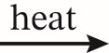 2NaAlO₂(s) + H₂O(g)
SiO₂ | acidic | SiO₂(s) + 2NaOH(s) Na₂SiO₃(s) + H₂O(l)
P₄O₁₀ | acidic | P₄O₁₀(s) + 12NaOH(aq) → 4Na₃PO₄(aq) + 6H₂O(l)
SO₂  SO3 | acidic | SO₂(g) + 2NaOH(aq) → Na₂SO₃(aq) + H₂O(l)  SO₃(l) + 2NaOH(aq) → Na₂SO₄(aq) + H₂O(l)
Other acceptable equations may include reactions of P4O10, SO2 and SO3 with water. Ionic equations are also acceptable. State symbols are not required.
  - Mg: 1s²2s²2p6³s²
S: 1s²2s²2p⁶3s²3p⁴
  - By losing one of its 3s electrons, magnesium gets closer to the stable electron configuration [Ne]. In contrast, when sulfur loses one of its 3p electrons, it gets further from the next stable electron configuration [Ar]. Therefore, the IE₁ of magnesium is lower than that of sulfur.
Magnesium can gain an electron only by accommodating it in the next energy sublevel, 3p, which is unfavourable. In addition, this will bring magnesium further from the stable electron configuration [Ne]. In contrast, sulfur can accommodate an extra electron in its partly filled 3p sublevel and get closer to the next stable electron configuration [Ar]. Therefore, the EA of sulfur is lower (more negative) than that of magnesium.
Notice that explanations based on the positions of magnesium and sulfur in the periodic table, general trends of IE₁ and EA in periods or the nuclear charges and atomic sizes of these elements will not be accepted because your answer must refer to electron configurations from part (b).
  - ²⁴Mg²⁺: 12 protons, 12 neutrons, 10 electrons.
  - Similarities: both bonding types involve electrostatic attraction; in both cases, valence electrons are involved.
Differences: bonding is metallic in Mg(s) but covalent (non-polar) in S(s); valence electrons are delocalized in Mg(s) but localized (shared between specific pairs of atoms) in S(s); valence electrons are attracted to Mg²⁺ ions in Mg(s) but to atomic nuclei in S(s); bonding is non-directional in Mg(s) but directional in S(s).
  - In the following calculations, some intermediate results are rounded to four significant figures (one more than needed). The final results are rounded to the correct number of significant figures (three).
    - Mg(s) + S(s) → MgS(s)
n(Mg) = $\frac{0.500 g}{24.31 g {mol}^{-1}}≈0.02057 mol$
n(S) = $\frac{0.500 g}{32.07 g {mol}^{-1}}≈0.01559 mol$
Sulfur is the limiting reactant, so n_{theor}(MgS) = n(S) = 0.01559 mol
m(MgS) = 0.01559 mol × (24.31 g mol⁻¹ + 32.07 g mol⁻¹) ≈ 0.879 g
If sulfur is used up completely, there will be 0.02057 − 0.01559 = 0.00498 mol of unreacted magnesium in the final mixture.
    - m_{final}(Mg) = 0.00498 mol × 24.31 g mol⁻¹ ≈ 0.121 g
m_{final}(mixture) = 0.879 g + 0.121 g = 1.000 g
$$ω\left(MgS\right)=\left({0.879 g \atop 1.000 g}\right)×100\%=87.9\%$$
$$ω\left(Mg\right)=100\%-8709\%=12.1\%$$

    - Your answer should include any two of the following:
  - the solid dissolves
  - bubbles of gas are produced
  - the mixture/solution becomes warm/hot
  - a smell of rotten eggs appears.
Notice that the smell might not appear if the experiment is carried out in a fume cupboard. Answers like “magnesium sulfide reacts with the acid”, “hydrogen sulfide is given off”, “energy is released” or “magnesium chloride forms” will not be accepted because you must refer to observable changes, such as changes in state, temperature, odour and so on.
    - n(H₂S) = $\frac{1.65 g}{34.09 g {mol}^{-1} }≈0.0484 mol$
V(H₂S) = 0.0484 mol × 24.8 dm3 mol⁻¹ ≈ 1.20 dm³
Notice that the V_{m} value at SATP (standard pressure and T = 298 K) is 24.8 dm³ mol⁻¹ rather than 22.7 dm³ mol⁻¹ (see practice problem 3 in Structure 1.5).
  - In the solid state, all Mg²⁺ and S²⁻ ions occupy fixed positions in the crystal lattice and cannot move. In molten magnesium sulfide, these ions move freely and thus can carry electrical charge through the sample.

  - Iodine and bromine are both non-metals with similar electronegativities (2.7 and 3.0, respectively), so the I–Br bond is covalent.
Alternatively, your answer can be based on the bonding triangle: Δχ = 3.0 − 2.7 = 0.3,
$\overline{χ}=\frac{(3.0+2.7)}{2}≈2.9$, so the bond is covalent.
  - Simple molecular, as both elements in IBr are covalently bonded to each other and have complete octets of electrons. Another reason is the fact that IBr is volatile under standard conditions and it has low melting and boiling points.
  - Dipole–dipole forces (as the I–Br bonds are slightly polar due to the slight difference in electronegativity between iodine and bromine) and London dispersion forces (as these forces exist in all substances).

    - s
T | p | Effect | Reason
decreases | constant | shifts left | the forward reaction is endothermic $∆H^{⊖}>0$, so the reverse reaction will produce extra heat to partly compensate the decrease in temperature
constant | increases | none | the total number of gas molecules on the left (reactant side) is the same as that on the right (product side) so changing pressure has no effect

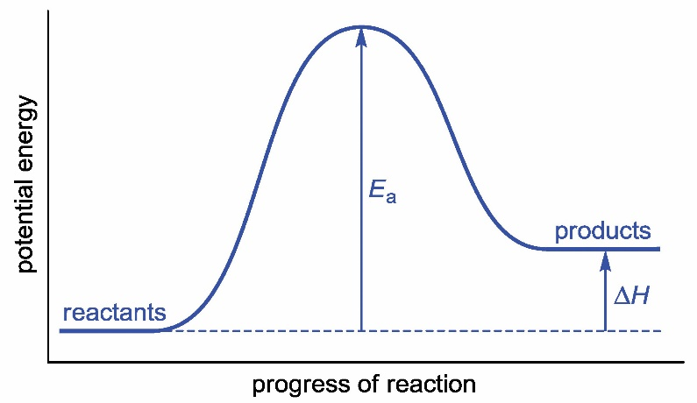
Notice that all labels are required and the potential energy of the products must be higher than that of the reactants (because$∆H^{⊖}>0).$

    - Oxidizing agent: iodine(I) bromide, IBr(s).
Reducing agent: sodium thiosulfate, Na₂S₂O₃(aq). The answers “thiosulfate ions” or “S₂O₃²⁻” are also acceptable.
Notice that iodine(I) bromide gains electrons while thiosulfate ions lose electrons:
IBr(s) + 2e⁻ → I⁻(aq) + Br⁻(aq)
2S₂O₃²⁻(aq) → S₄O₆²⁻(aq) + 2e⁻
    - n(IBr) = $\frac{3.10 g}{206.80 g {mol}^{-1}}≈0.0150 mol$
n(Na₂S₂O₃) = 2 × n(IBr) = 2 × 0.0150 mol = 0.0300 mol
V(Na₂S₂O₃) =$\frac{0.0300 mol}{0.100 mol {dm}^{-3}}≈0.300 {dm}^{3}$

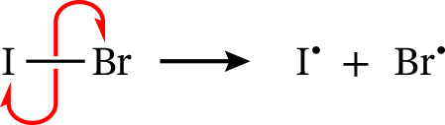

    - MgCO₃(s) + H₂SO₄(aq) → MgSO₄(aq) + CO₂(g) + H₂O(l)
MgCO₃(s) + 2H⁺(aq) → Mg²⁺(aq) + CO₂(g) + H₂O(l)
Either molecular or ionic equation (involving H⁺ or H₃O⁺) scores the mark.
Notice that carbonic acid, H₂CO₃(aq), is unstable and thus it is not acceptable as the reaction product.

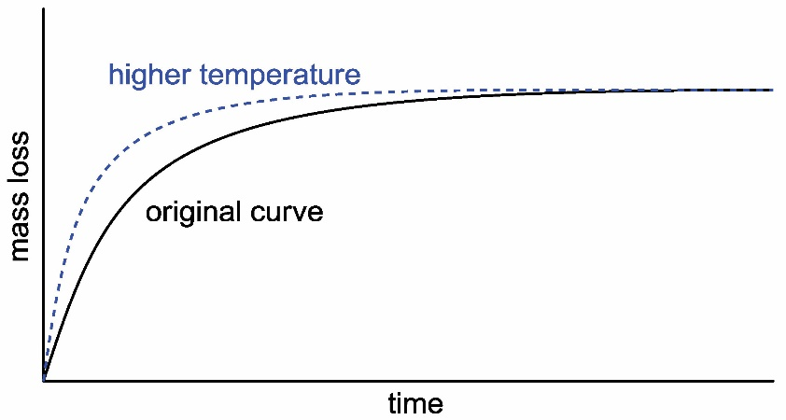
Notice that the curve for a higher temperature must flatten out at the same level as the original curve, as temperature does not affect the quantities of reactants and thus the final mass loss.

    - According to section 1 of the data booklet, Q = mcΔT. We can assume that dilute sulfuric acid is almost pure water (ρ = 1.00 g cm⁻³ and c = 4.18 J g⁻¹ K⁻¹) and the heat capacity of the solid sample is negligible. In that case:
m₁ = m₂ = 100 cm³ × 1.00 g cm⁻³ = 100 g
ΔT₁ = 23.2 − 21.4 = 1.8 K
ΔT₂ = 29.6 − 21.5 = 8.1 K
Q₁ = 100 g × 4.18 J g⁻¹ K⁻¹ × 1.8 K ≈ 750 J = 0.75 kJ
Q₂ = 100 g × 4.18 J g⁻¹ K⁻¹ × 8.1 K ≈ 3400 J = 3.4 kJ
    - The difference between Q₁ and Q₂ is due to the heat absorbed by the decomposition of magnesite:
MgCO₃(s) + H₂SO₄(aq) → MgSO₄(aq) + CO₂(g) + H₂O(l) ΔH₁
MgO(s) + H₂SO₄(aq) → MgSO₄(aq) + H₂O(l) ΔH₂
MgCO₃(s) → MgO(s) + CO₂(g) ΔH₃
To obtain the third equation, you need to subtract the second equation from the first. According to Hess's law, ΔH₃ = ΔH₁ − ΔH₂. Therefore:
n(MgCO₃) = $\frac{2.00 g}{84.32 g {mol}^{-1} }≈0.0237 mol$
ΔH₁ = $\frac{-0.75 kJ}{0.0237 mol}≈-31.6 kJ {mol}^{-1}$
n(MgO) = n(MgCO₃) = 0.0237 mol
ΔH₂ = $\frac{-3.4 kJ}{0.0237 mol}≈-143 kJ {mol}^{-1}$
(Negative signs for ΔH1 and ΔH1 are used because both reactions are exothermic.)
ΔH₃ = −31.6 kJ mol⁻¹ − (−143 kJ mol⁻¹) ≈ 111 kJ mol⁻¹

  - 3-methylbutan-1-ol
  - Any saturated ether with five carbon atoms will score the mark, for example:
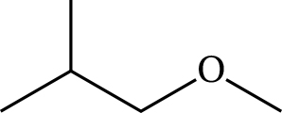
  - Reagents: acidified potassium dichromate/acidified potassium permanganate/oxidizing reagent.
Conditions: heating under reflux.
  - Oxidation of the alcohol under reflux produces 3-methylbutanoic acid, (CH₃)₂CHCH₂COOH. By losing a proton, this acid produces its conjugate base, (CH₃)₂CHCH₂COO⁻.
  - First, an aqueous solution with a certain concentration of Y is prepared. Then a certain property of that solution is measured or determined visually. The property can be any of the following:
  - pH (the lower the pH, the stronger the acid)
  - electrical conductivity (the higher the conductivity, the stronger the acid)
  - temperature change upon addition of a certain amount of a base (the greater the temperature change, the stronger the acid)
  - rate of dissolution of a metal or metal oxide/carbonate/hydrogencarbonate (the faster the solid dissolves, the stronger the acid)
  - intensity of effervescence (production of bubbles) upon addition of a certain amount of a metal/metal carbonate/metal hydrogencarbonate (the more gas produced per unit time, the stronger the acid).
A more accurate estimation can be obtained by running any of the above experiments side by side with a solution of another (known) acid of the same concentration and comparing the two measured values or observations. However, notice that the strength of acid Y needs to be estimated, not determined precisely, so the calculation of pK_{a} is not required.

    - $K=\frac{\left[I_{2}\right][{Br}_{2}]}{[IBr]^{2}}$
    - T = 135 + 273 = 408 K
$∆G_{decomp}^{⊖}$(IBr) = 7.2 kJ mol⁻¹ = 7200 J mol⁻¹
The reaction involves two moles of IBr, so the ${∆G}^{⊖}$value for the reaction is 2 × 7200 J mol⁻¹ = 14 400 J mol⁻¹.
According to section 1 of the data booklet, ${∆G}^{⊖}$= −RTInK, so:
$$\ln{K}=\frac{14 400 J {mol}^{-1}}{8.31 J K^{-1}{mol}^{-1}×408 K}≈-4.25$$
K = e^{−4.25} ≈ 0.014

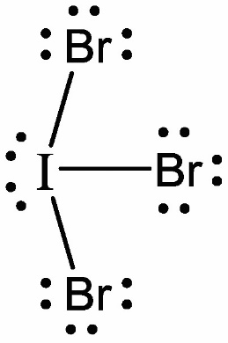
Each bonding and lone electron pair can be represented by either two dots or a line.
    - Electron domain geometry: trigonal bipyramidal (because there are five electron domains around the iodine atom, including three bonding electron pairs and two lone electron pairs).
Molecular geometry: T-shaped (because both lone electron pairs occupy equatorial positions to minimize the mutual repulsion between the electron domains).
  - According to the Lewis theory of acids and bases, this is a neutralization reaction. The Lewis base IBr donates one of its lone electron pairs to the empty electron orbital of the Lewis acid FeBr₃.

    - The concentration of H⁺(aq) ions is proportional to the concentration of sulfuric acid:
H₂SO₄(aq) → 2H⁺(aq) + SO₄²⁻(aq)
When c(H₂SO₄) doubles, the initial rate also doubles, so the reaction is first order with respect to H⁺(aq) ions.
    - As follows from part (i), ν = k[H⁺], so k = $\frac{v}{[H^{+}]}$. The k values at two different temperatures (21.4 and 35.2 °C) can be calculated using the data in the first and third rows of the table. The two pairs of k and T values can be substituted into the Arrhenius equation, which is given in section 1 of the data booklet. Solving the system of these two equations will give the E_{a} value.
Alternatively, the two pairs of k and T values can be used to draw the graph of the logarithmic Arrhenius equation, as shown in example 6 of Reactivity 2.2. The E_{a} value can be found from the slope of the graph.
  - According to section 13 of the data booklet, $S^{⊖}(CO_{2},g)$ = 214 J K⁻¹ mol⁻¹. Therefore:
$∆S_{decomp}^{⊖}$ (MgCO₃, s) = 27 + 214 − 66 = +175 J K⁻¹ mol⁻¹
  - According to section 1 of the data booklet, ${∆G}^{⊖}$=${ ∆H}^{⊖}-{T∆S}^{⊖}$. The decomposition will become favourable when ${∆G}^{⊖}>0.$ Therefore:
111 kJ mol − T × 0.175 kJ K⁻¹ mol⁻¹ < 0
(Notice that${ ∆S}^{⊖}$ has been converted to kJ K⁻¹ mol⁻¹ to match the units of${ ∆H}^{⊖}$).
111 < T × 0.175 K⁻¹
T > 634 K
Therefore, the decomposition will become favourable at T > 634 − 273 = 361 °C.
(If you used${ ∆H}^{⊖}$= 100 mol⁻¹ and ${ ∆S}^{⊖}$ =200 J K⁻¹ mol⁻¹, your answer should be T > 227 °C.)
  - Both MgO(s) and CaO(s) are ionic compounds, so their lattices consist of doubly charged cations and doubly charged anions. However, Mg is higher in group 2 of the periodic table than Ca, so the ionic radius of Mg²⁺ is smaller than that of Ca²⁺. The smaller cations Mg²⁺ experience stronger electrostatic attraction to O²⁻ anions, so the ionic bonding in MgO(s) is stronger than that in CaO(s). Therefore, the lattice enthalpy of MgO(s) (3791 kJ mol⁻¹) is greater than the lattice enthalpy of CaO(s) (3401 kJ mol⁻¹).

  - KOH(aq) → K+(aq) + OH⁻(aq)
[OH⁻] = 0.0100 mol dm⁻³
[H⁺] =$\frac{K_{w}}{[OH]^{-}}=\frac{1.00×{10}^{-14} {mol}^{2}{dm}^{-6}}{0.0100 {mol dm}^{-3}}$ = 1.00 × 10⁻¹² mol dm⁻³
pH = −log[H⁺] = −log(1.00 × 10⁻¹²) = 12.00
Alternative solution:
pOH = −log[OH⁻] = −log(0.0100) = 2.00
pH = 14 − pOH = 14 − 2.00 = 12.00

  - The pH at the equivalence point is approximately 8.2 (see part (e)), so the best indicator is phenol red (pK_{a} = 7.9). Two other indicators, bromothymol blue (pK_{a} = 7.0) and phenolphthalein (pK_{a} = 9.6), can also be used, as their pK_{a} values are within the pH jump of the titration curve.
  - The equivalence point is reached at V(KOH) = 12.0 cm³ = 0.0120 dm³, so:
n(KOH) = 0.0100 mol dm⁻³ × 0.0120 dm³ = 1.20 × 10⁻⁴ mol
  - HA(aq) + KOH(aq) → KA(aq) + H₂O(l)
n(HA) = n(KOH) = 1.20 × 10⁻⁴ mol
m(HA) = 7.21 mg = 7.21 × 10⁻³ g
M(HA) = $\frac{7.21×{10}^{-3} g}{1.20×{10}^{-4} mol}$ ≈ 60.1 g mol⁻¹
  - The pK_{a} of the acid is equal to the pH value at the half-equivalence point:
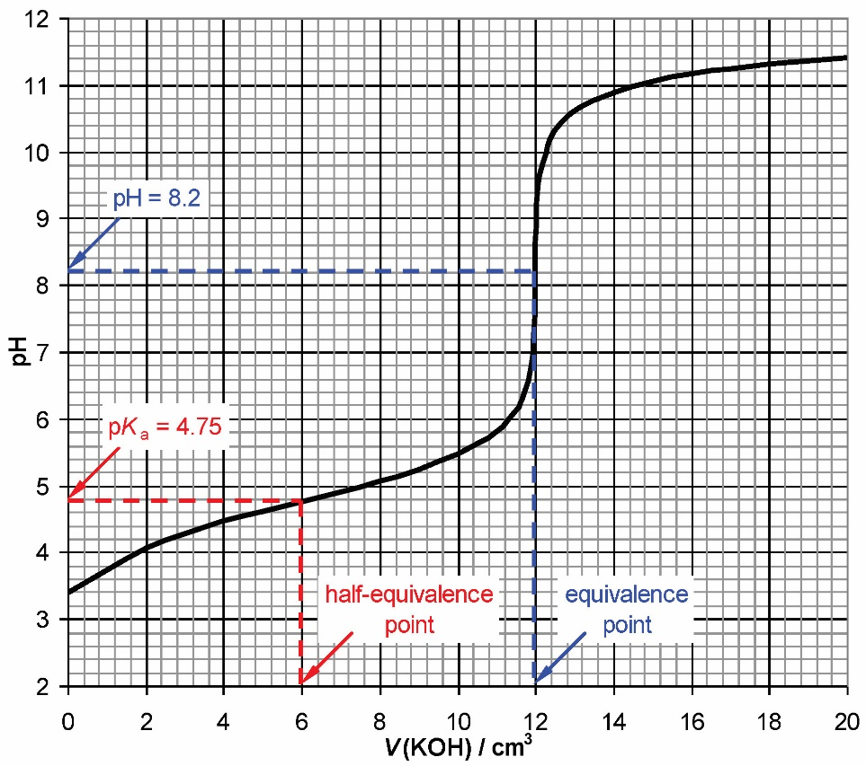
Notice that the equivalence point is reached at V(KOH) = 12.0 cm³, so the half-equivalence point is reached at V(KOH) = 6.0 cm³. The acceptable range for pK_{a} values is 4.7–4.8.
  - A monoprotic carboxylic acid (RCOOH) contains one COOH group with M_{r} = 45.02. If M_{r}(RCOOH) = 60.1, then M_{r}(R) = 60.1 − 45.02 ≈ 15, so R = CH₃. Therefore, it is ethanoic acid:
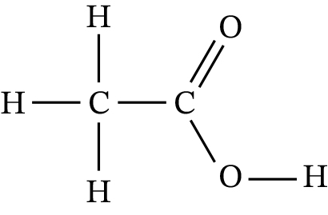
Notice that a condensed formula, such as CH₃COOH, is not acceptable because a full structural formula is required.

  - At higher frequencies, the emission or absorption lines in the line spectrum of titanium become closer to one another and eventually converge. The IE₁ of titanium can be found from the formula IE₁ = hf, where h is the Planck's constant and f is the frequency at the limit of convergence.

    - The oxidation state of titanium is +3 in the first ion and +4 in the second ion.
Notice that the answers “3+” and “4+” would not be accepted.
    - The first ion, [Ti(H₂O)₆]³⁺, is coloured because the central atom in this ion has one 3d electron (while in the second ion it has none). The energy of electron transitions within the 3d sublevel corresponds to the frequency of visible light.
    - The wavelength 580 nm corresponds to yellow light. If yellow light is absorbed, the light of the complementary colour (violet) is transmitted, so the complex appears violet.
Notice that in reality this complex appears purple rather than violet because the absorption at 580 nm is very broad and it covers the range from 500 to 640 nm. As a result, the complex absorbs not only yellow but also green and orange light. The complementary colours to green and orange are red and blue, respectively. The combination of red, blue and violet light produces the characteristic purple colour of Ti(III) complexes.

    - 2Ti(s) + 3Ni²⁺(aq) → 2Ti³⁺(aq) + 3Ni(s)
or
Ti(s) + 1.5Ni²⁺(aq) → Ti³⁺(aq) + 1.5Ni(s)
(Either equation is acceptable.)
    - $E_{cell}^{⊖}$ = −0.26 V − (−1.21 V) = +0.95 V
Notice that the standard potential for a voltaic cell must be positive because the cell reaction is spontaneous.
  - CH₃OH(aq) + H₂O(l) → 6H⁺(aq) + CO₂(g) + 6e⁻

  - Your answer may include the discussion of any two techniques outlined in table 8 of Structure 2.2.
  - Equation: C₆H₆ + HNO₃ → C₆H₅NO₂ + H₂O
Conditions: mixture of concentrated nitric acid and concentrated sulfuric acid and heat.

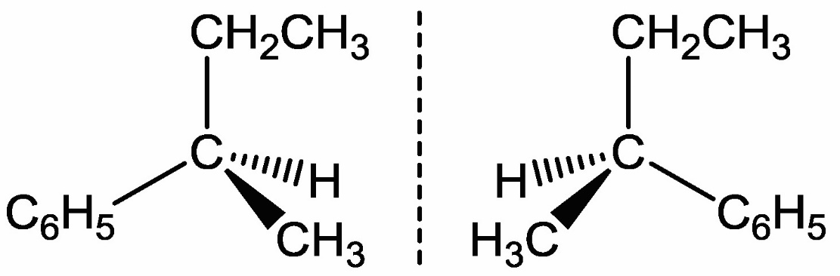
    - Four signals with the integration ratio 1 : 2 : 3 : 3.
Notice that the protons of CH₃ groups in the CH₂CH₃ and CHCH₃ fragments are in different chemical environments, so they produce two signals, not one.
    - 2850–3090 cm⁻¹ (C–H vibrations).
    - Either fractional distillation or chromatography (any one is sufficient for the mark).
    - Bromine water (but-1-ene will decolourize it while the reaction product will not).

